Big Black Card (BBC) Automated Teller Machine User Manual

Table of Contents

1. *Introduction*………………………………………………… 1 2. *User Authentication*……………………………………… 1

3. *Main Menu*…………………………………………………… 2

3.1. Check Balance

3.2. Withdrawal

3.3. Exit

4. *Check Balance*……………………………………………… 2

5. *Withdrawal*………………………………………………….. 3

6. *Exit*……………………………………………………………… 3

7. *Currency Conversion…………………………………….* 4

8 *. Displaying Balance……*………………………………… 4

1. Introduction

Welcome to the Big Black Card (BBC) ATM User Manual. This guide will help you explore the features of the BBC ATM application.

1. User Authentication

* Enter your 4-digit PIN when prompted.

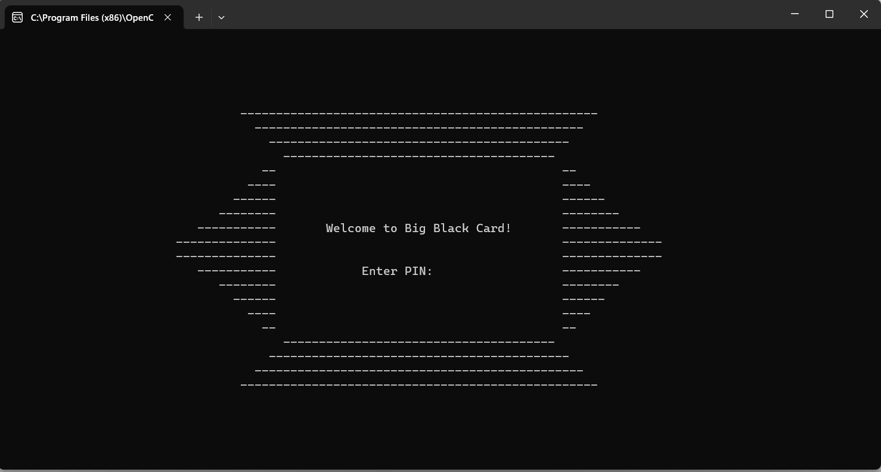

1. Main Menu

After authentication, choose from the following options:

* Check Balance (Option 1)
* Withdrawal (Option 2)
* Exit (Option 3)

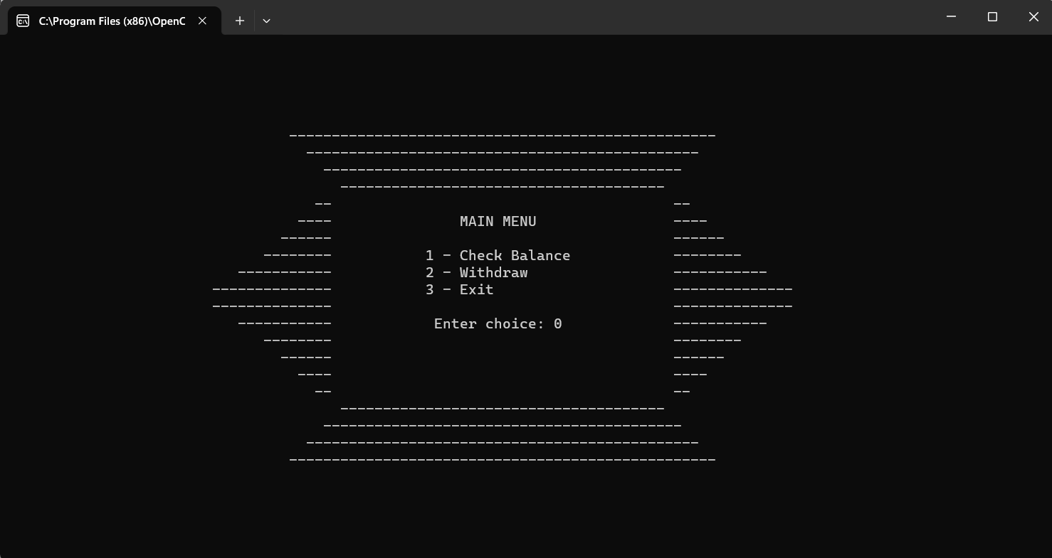

1. Check Balance

Select "1" from the Main Menu to check your account balance in PHP, USD, INR, and JPY.

* The currency of the balance in your account will be automatically converted into other currencies

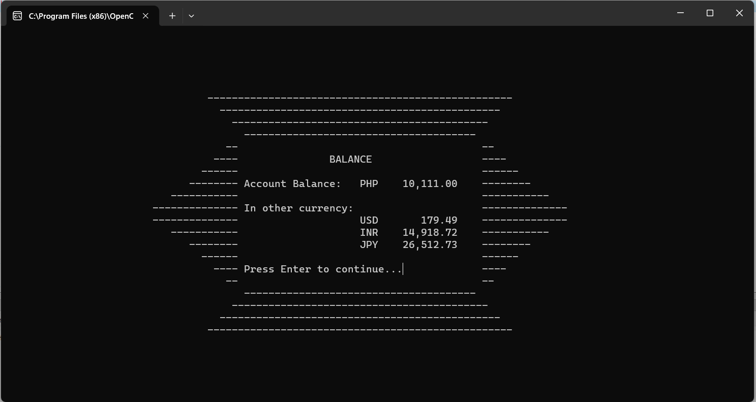

1. Withdrawal

Select "2" from the Main Menu, enter the withdrawal amount, and follow on-screen instructions.

* When you make a withdrawal from your account, the your balance.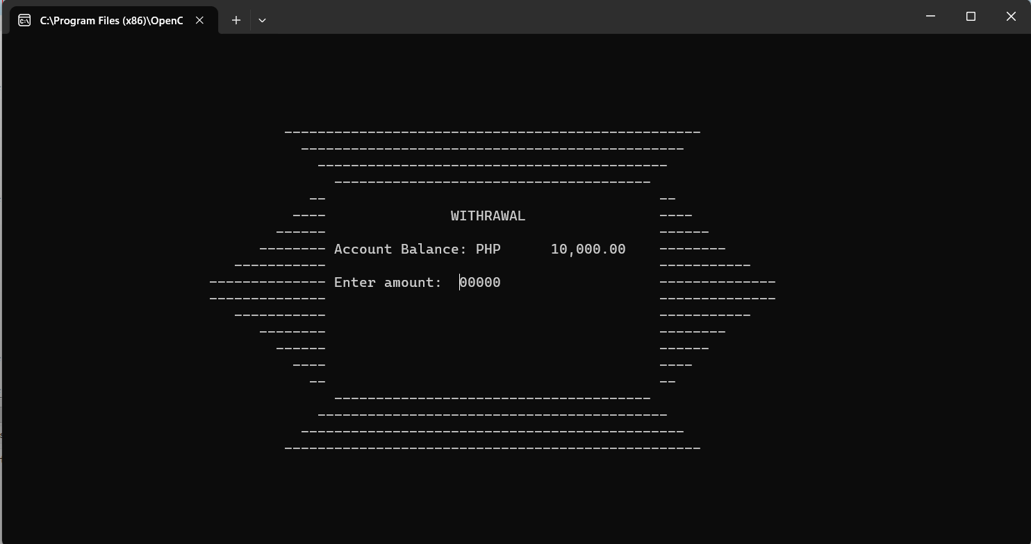

1. Exit

Select "3" from the Main Menu to exit the BBC ATM application.

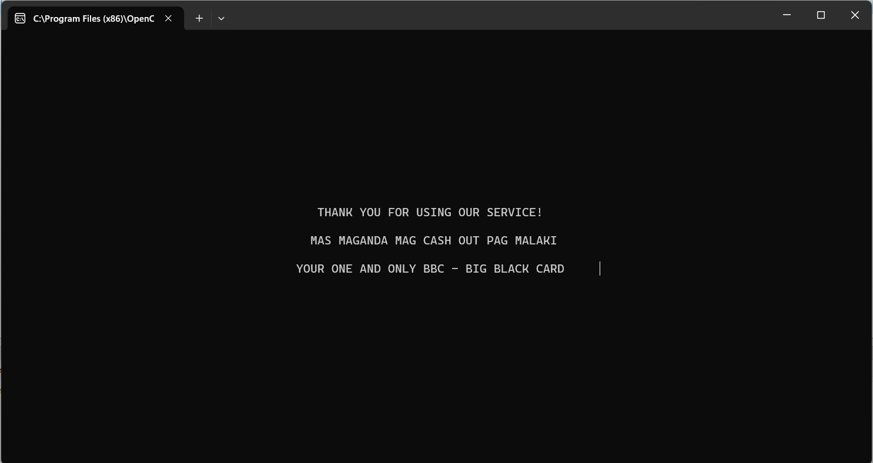

1. Currency Conversion

Balances are automatically converted when checking. USD, INR, and JPY are displayed alongside the PHP balance.

1. Displaying Balance

After transactions, updated balances will be displayed.

